Preface
This text represents a breakthrough in the field of education, a new way to shape classroom dynamics with purpose and precision. It introduces a curriculum technology: a set of theoretical tools designed for real-world application, enabling educators to achieve better outcomes. Like any effective tool, its true value lies in how it transforms practice, allowing more impactful teaching, deeper learning, and classroom environments that align with how the human mind naturally learns.
The foundation of this methodology emerged from an unexpected intersection: physical training, education, and mechanical engineering. Through observation and pattern recognition, I discovered compelling parallels between these fields. Just as the body grows stronger through challenge and recovery, the mind develops through focused effort and reflection. And just as engineers design systems for efficiency and durability, we too can design educational systems that work with, not against, the brain’s natural architecture.
This discovery felt akin to how Pythagoras determined the unknown side of a triangle by understanding the other two. I connected familiar pieces in a new way to uncover something previously unseen.
Underlying this work is a universal principle: the universe is interconnected, often applying the same design logic across different domains. Education, when viewed through this lens, is not merely a social construct; it is a dynamic and multifaceted entity. It is a natural system, waiting to be understood and optimized. In that sense, my work is not one of invention, but of discovery. Like an archaeologist unearthing what has long been buried, I have revealed what I call a Technology of the Mind.
This is not a metaphor. It is a new way of thinking. It is a scientific approach that merges neuroscience, engineering design principles, and empirical observation to explore the true nature of learning. Just as Pythagoras uncovered mathematical truths by recognizing patterns in nature, I have developed this framework through empiricism, the belief that knowledge comes from observation and experience. This principle, championed by Aristotle, forms the foundation of my approach to understanding education.
What follows is not abstract theory. It is a practical system. It is a set of tools designed to reshape classroom dynamics in line with how people truly learn. Offering this to educators is like placing an excavator in the hands of someone who has only known a shovel.
This is not a small improvement. It is an evolution.

Chapter 1: The Problem

The Parameters of a Book-Based Educational System
I have a deep respect for teachers and the important role they play in our society. If it were up to me, I would pay them $100,000 a year because they are truly at the forefront of shaping the future. However, as much as I respect teachers, they are often misguided by the system in which they are part. Teachers are trained within an educational structure that focuses heavily on degrees, tests, and memorization. They, in turn, pass on this framework to their students, even though it may not be the best way to prepare them for real-world challenges. The system itself is built on outdated methods, and teachers are constrained by these parameters, even though they may not always agree with them.
The current educational system is based on books, theories, and memorization, rather than on practical skills that can be used in the real world. While this system helps pass down knowledge, it does not fully prepare students for the jobs they will face after graduation. Instead of focusing on skills that can be applied in real situations, schools emphasize earning degrees. As a result, students often graduate with knowledge they may never use, and without the hands-on experience needed to succeed in their careers. The education system has become about following a set path, completing assignments, and obtaining a degree, rather than truly learning or understanding the material.
The system teaches students that getting a degree is the key to finding a job, but this is not always true. In reality, employers are looking for people with practical skills, not just academic qualifications. Many graduates enter the workforce and find that they need additional training because the knowledge they gained in school is not directly applicable to the job. This creates a cycle where students focus on earning degrees instead of learning skills that would make them ready for the workplace.
The result is that many graduates have degrees, but they lack the hands-on skills employers are looking for. Just like in the gym, where people may lift weights for appearance rather than strength, students often work hard in school without seeing how it will help them in real-life situations. They go through the motions of completing assignments and exams simply to earn a degree, without fully understanding why they are learning what they are learning. This approach to education needs to be rethought.
The following chapters will explore how we can change the system to focus more on practical skills and real-world knowledge, instead of just degrees.
No Harmony
There is a great effort put into formal education to train people, yet many individuals still lack basic life skills such as social skills, cooking skills, and job-related skills. In Canada alone, the government spends over 53 billion dollars a year on education. People spend 24 years of their lives in educational institutions, and when they graduate, it’s often difficult to find a job, even in the field they studied.
Despite Canada’s education system being one of the best in the world, there is a clear disconnect between what is taught and what is required in the workforce. This mismatch contributes to Canada’s 14.2% youth unemployment rate. By 2020, it was estimated that 40% of all new jobs would be in the skilled trades and technology sectors, areas that traditional education doesn’t focus on enough. Companies, therefore, have to rely on themselves to train employees, with the average large company spending around 19 million dollars a year on training. This is because the knowledge students gain in school does not always align with the knowledge needed in real life and the workforce.
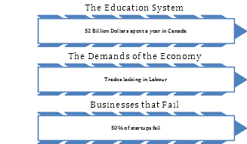
The core issue is that the demands of the educational system do not cater to the demands of life. It’s similar to the gym: people often work out with no real functional purpose, striving for a superficial ideal. In the same way, the education system creates a mold that is disconnected from the practical needs of the real world. If the system produced individuals with truly relevant skills, there would be no unemployment. After all, what employer would refuse a skilled, capable worker? The reality is that our system is dysfunctional; there is no harmony between what is taught and what is needed.
So, how do we create a practical curriculum? The answer lies in making the curriculum relevant to the real world. The more closely the education system reflects the skills needed in everyday life and the workforce, the more intuitive and effective it becomes. A curriculum based on real-world needs will naturally produce individuals who are prepared, capable, and ready to succeed in the job market.
Kinetic Intelligence
The Parameters of the Bodybuilding Philosophy
The gym culture shares similarities with the education system in that both environments are designed around specific parameters that may work well within their own context but fail to address the demands of the outside world. In the gym, the focus is on muscle mass and appearance, which is why bodybuilding competitions showcase individuals demonstrating their massive physiques.
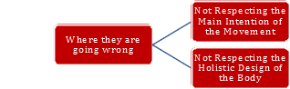
The equipment is designed to isolate and apply resistance to specific muscle groups. While there is value in this, the gym misses the mark in two important ways:
i. Main Intention of Natural Design
Each muscle group in the body has a primary function, even though it can be involved in various movements. The body's muscles are designed to perform one essential movement, and in most cases, that movement is forward propulsion. Take the calves, for example. In the gym, the main exercise for the calves is often the calf press, where the ankle moves up and down.
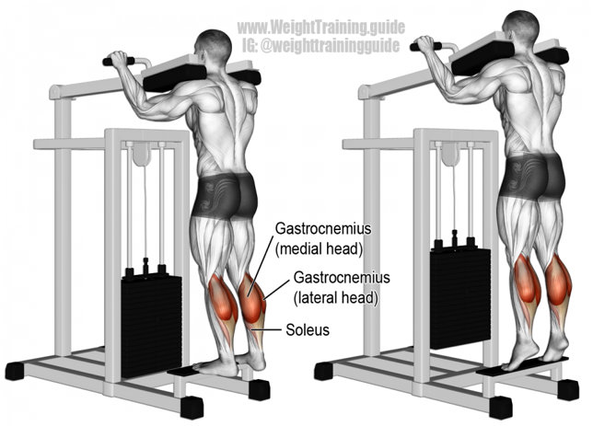
While this exercise works the muscle, it is not the main function of the calf muscle. The calf's primary role is to propel the body forward as we walk. This forward motion is how the body achieves movement and is something we do repeatedly every day. However, this core movement is rarely practiced in conventional gym training, which focuses more on isolated exercises.
ii. The Main Function of the Body: Forward Motion
The primary function of the entire body is to move forward, transportation. This forward motion is essential, yet the gym often isolates body parts and asks them to perform movements that don’t mimic real-life demands. The problem in the gym is that people are stationary, moving only specific body parts with resistance, whereas the body is naturally designed to move in a forward direction. This forward movement is what life requires, but the gym doesn’t train for it because its design doesn’t take this into account.
The Educational System's Disconnect
Similarly, the educational system trains students in ways that are disconnected from the real-world demands of life and the economy. Students are taught to perform exercises, both mental and academic, that have little relevance to the actual challenges they will face in their careers or everyday lives. Just like the gym’s focus on isolated muscle movements, the education system often prioritizes abstract knowledge or specific tasks that don't always prepare students for the realities of the workforce. It becomes an isolated entity, separate from the needs and demands of the real world.
Muscular Context
When we move in a forward motion, we are using our muscles in the way they were naturally designed to move. In other words, we are activating them in their primary function as a whole. To take it even further, I added resistance to this forward motion to strengthen the entire body in its most natural movement. By doing this, I was aligning with the body’s design and reinforcing the motion it performs most often. This approach became a holistic form of training, increasing the body’s functionality in the way it was meant to move. This is what I mean by relevance: training in a way that respects and enhances the body’s primary function.

One day, while working in my backyard, I saw a log, and it suddenly clicked. The idea of forward motion, adding resistance, and incorporating balance all came together. To my surprise, it worked exactly as I had imagined. It significantly improved my body’s functionality.
Relevance means respecting the body’s primary design and reinforcing it in ways that enhance its natural movement and capabilities.
Relevancy
The same principle applies to knowledge. Just as the body thrives when it moves in its natural direction, intellectually, if we study subjects that are most relevant to our lives, we become masters of life. The key question is: What is the main intellectual movement that life demands, and how can we put resistance to it in a way that helps us gain mastery? How can we apply the principle of relevancy to education?
To answer this, we first need to ask: What are the demands of life?
Knowledge is Strength, Strength is Power
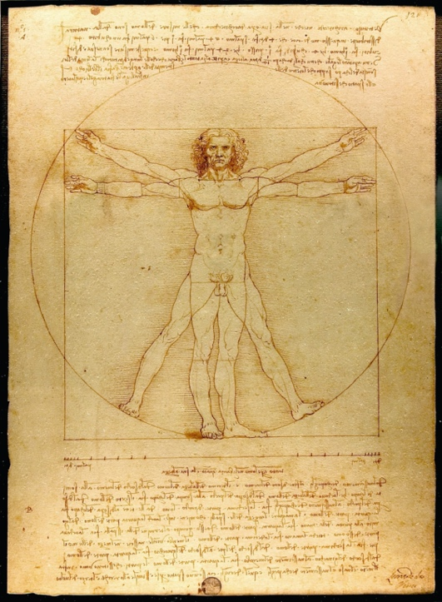
The more applicable a subject is to our everyday life, the more valuable it becomes. For example, food: we need to eat three times a day for the rest of our lives. It’s an ongoing, essential task, making food a highly relevant subject. Similarly, psychology is crucial because, as social creatures, our ability to interact with others plays a major role in our well-being. The better our people skills, the more successful we are in life. Therefore, we prioritize subjects based on how often and how significantly we use them.
Curriculum Development: Making Knowledge Relevant
Many of these important subjects, like food, psychology, and social skills, already exist within academia. However, we need to unify them into a single, common curriculum. We must redefine the baseline knowledge that should be shared by everyone, regardless of their chosen path. Take the traditional high school curriculum, for example. It covers many subjects, but often, they don’t feel immediately applicable to the realities of life.
A strategy for curriculum development should involve prioritizing knowledge based on its relevance to life. It’s not enough to simply present students with theoretical concepts; they need to actively apply what they’ve learned. The exercises and experiences in education should focus on real-world applications so that students can see the practical value of what they are learning.
Main Function – Reinforce – High Performance
The Curriculum – The Functionality of Knowledge
Often, what we learn in school seems disconnected from the real world. Teachers may provide exercises, but they often don’t have a direct link to practical application. However, skills are meant to serve a useful purpose in reality. The value of knowledge lies in how it can be applied to real-life situations. The more ways you can use a tool or piece of knowledge, the more valuable it becomes.
Take, for example, the human hand. It is a brilliant design, incredibly multifunctional, and serves as a cornerstone of intelligent life.
“The better thought-out something is, the less complicated it needs to be, yet the more functional it is.”
This is because, much like nature, everything in existence is the result of thought. The realm of thought, the sub-reality, is more real than the physical world that we can see. This forms the trinity of existence: Soul – Thought – Physical, as shown by the fact that everything begins with thought.
This understanding redefines value. True value lies in functionality. Just as tools serve specific functions, so does knowledge. Whether it’s carpentry or psychology, each field arose from a real-world need and serves a distinct function. An educational curriculum should answer the question: What does the world need? From this, we can determine what skills to develop. Much like a business asks, What do my clients need?, education should cater to the needs of humanity and existence.
Education (catered to the job) → Job (catered to reality) → Reality

The Multidisciplinary Philosophy of Usefulness
You can acquire a range of skills, but the ones that truly matter are the ones you use most often, skills that directly relate to the job at hand. This philosophy can help prioritize your knowledge, possessions, and physical needs. In this case, I apply it to engineering, education, and kinesiology.
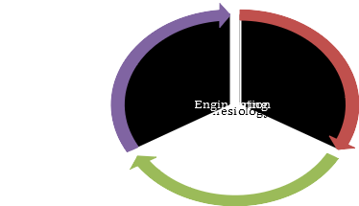
Engineering
The usefulness priority principle extends to the things we own. Many of us accumulate a lot of things, but we only use about 20% of them. Each item serves a specific purpose, such as for a particular sport, and we often have multiple items for that purpose. What truly matters is what you use.
When designing anything, you must first identify the parameters of real-world needs and predict how to design towards those needs while avoiding unnecessary elements. Then, unlock the blueprint based on these parameters.
For example, consider the design process of a car. Mechanical engineering is about innovatively organizing materials to achieve a physical function that addresses a real-world need—transportation. The thought process for a car includes:
- Transportation: The core purpose of the car.
- Combustion: Using the combustion principle to power the vehicle.
- Passenger transportation: Ensuring the design accommodates passengers.
- Comfort: Adding features like air conditioning and radio to enhance the experience, temperature control for comfort, and entertainment for the mind.
Define Your Needs – Expanding on It
When designing a need-based infrastructure, you must take a holistic approach, addressing all the demands that come with what you're trying to create. Nature does this brilliantly. Whether it’s our bodies, a blade of grass, or the cosmos, we see clear evidence of intelligent design that caters to a wide range of needs. This is the kind of model we should base our parameters on, much like how thinkers in the Renaissance and ancient China approached design.
Now, let’s apply this principle to something like a vehicle and expand its functionality for the sake of exercise.
- Imagine a passenger vehicle transformed into a recreational vehicle.
- Now, make it amphibious, so it can operate both on land and on water—like an amphibious bus.
This is what I mean by expanding the functionality of something.
Expanding Functionality: A Convertible, Adaptable Vehicle
Let’s take this even further. Imagine converting a regular passenger vehicle into a machine that can adapt to various weather conditions and terrains. This could include:
- An enclosed passenger body with interchangeable drive systems, such as a snowmobile belt drive in the back.
- A propeller for water, connected to the engine, enabling it to function as a boat.
- Even expanding the seating space by attaching an additional body at the back, similar to a caterpillar vehicle.
These innovations expand the vehicle’s functionality, making it adaptable to multiple conditions and needs.
The More You Need It – The More Important It Becomes
What I’m trying to show here is the importance of identifying your needs and reinforcing those needs with the things you own. It’s a prioritization principle based on necessity—a strategy for directing your resources in ways that increase overall functionality. By addressing your real needs, you enhance the usefulness of what you own, making it serve you better in different situations.
Usefulness Philosophy Applied to Education
Using the same principle, we can imagine what a curriculum might look like if it asked the question: What is used most in life? To answer that, we would need to look at life from different angles:
- Physical Needs: Such as the body and shelter.
- Mental Needs: Psychology, linguistics, and communication skills.
- Spiritual Needs: Practices like yoga and the arts that contribute to well-being and personal growth.
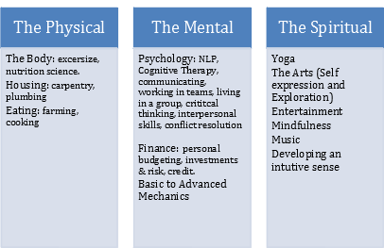
We need to look beyond traditional economic philosophy and consider the Darwinian principles of survival: What skills are most important for thriving in life? This could shape the curriculum, focusing on what we need most to survive, grow, and adapt in the world.
Mechanical Engineering and Our Role in Nature
Mechanical engineering is deeply connected to how we, as humans, fit into the broader context of nature. In essence, the purpose of engineering is to solve real-world problems and improve our relationship with the environment. Engineering solutions must respect the natural world, working in harmony with the environment to address our needs, whether for shelter, transportation, or sustainability.
Curriculum Design Based on the Need-Based Philosophy
The following diagram illustrates a curriculum designed with the need-based philosophy in mind. It shows how each subject is directly applicable to real-life situations, with an emphasis on solving practical problems. We can compare this model with the current standard curriculum to highlight the differences. (Consider hiring an illustrator to create a visual representation.)
Real-Life Problem Solving
The curriculum would focus on solving real-world problems, grounded in the challenges we face daily. Think of it as "social math"—practical knowledge tied to real situations. Some examples of real-life problems that should be included in the curriculum might include:
- What to do in a confrontation: Techniques for conflict resolution and handling stress.
- How to manage a delicate situation: Approaching sensitive topics with tact and care.
- How to buy a house: Understanding the steps, financing options, and legal aspects.
- How to learn about something when you don’t know it: Research strategies and critical thinking.
- Handwriting techniques: The basics of effective writing.
- How to impart new knowledge: Teaching methods and communication strategies.
- Making the best buying decisions: Consumer education and smart financial choices.
These are practical examples of knowledge that directly address the real needs of life. A curriculum focused on these areas would help students build skills that are immediately useful and relevant.

